# Analysis of Adverse Event Rates

In this section we compare the rate of Global and US reports of post-vaccination adverse events (AE), for the COVID-19 vaccine and the Flu vaccine. For each of the AE, we compare three relevant rates of reporting: i) the rate of reported AE per unit time, ii) the rate of reported AE per dose given, and iii) the rate of reported AE per person vaccinated.

In Table 0 below, we report the period used for normalizing the data, Global values are reported on the top line, US value on the second line.

| Vaccine | Time Tracked | Billion Doses Given | Billion People Vaccinated |
| --- | --- | --- | --- |
| COVID-19 | 18 Months | 12.07 0.596 | 5.23 0.260 |
| Flu | 294 Months | 66 (estimated) 3.3 | 9.23 (simulated) 0.389 (simulated) |

*Table 0*

Counting the number of people vaccinated with the COVID-19 vaccine is straightforward because there has only been one worldwide attempt at vaccination and the data has been tracked from day one. The Flu vaccine is harder because individuals are not tracked and there are yearly seasons where an individual may choose to receive a subsequent vaccinations. We run a Monte Carlo simulation to estimate the number of people that have received at least one Flu vaccine in the US since 1998.

We track a sample population where each year a fraction of the population is vaccinated, , a fraction of the population dies (some of whom may be vaccinated), , and a new fraction of the population is born (none of whom are vaccinated), . By simulating the demographics change yearly, we can estimate the total number of people who have received at least one flu vaccine by 2022. We use the UN population data to estimate and each year (reference: <https://population.un.org/>) and the conditional probability of Flu vaccination from Kwong, et al. (reference: <https://www.ncbi.nlm.nih.gov/pmc/articles/PMC6961264/>). Kwong reports that roughly 57% (33,234 out of 58,021) of the population in their study who receives a flu shot in one year repeats it a subsequent year. The CDC reports that approximately 50% of the population receives the vaccine in any given year. From that, we approximate for previously vaccinated individuals and for previously unvaccinated individuals, which will result in the rough CDC approximation of 50% of the population being vaccinated any given year.

To allow simulation “burn in” for the stochastic nature of this experiment, we start in 1980 with a sample of the US population of 100,000,000 people with 50% of them "pre-vaccinated" from previous years. From 1980 to 1997 we grow the population by , shrink it by , and vaccinate individuals by the conditional based on their current vaccination status, by 1997 we can see that the fraction of vaccinated population has stabalized. We continue the simulation until 2021 with the addition that in 1998 we start accumulating the number of people who were vaccinated and died. The results of that simulation are shown below in Table 00.

| End of Year | Sample Population (Thousands) | Vaccinated Population (Thousands) | Total Vaccinated Since 1998 (Thousands) |
| --- | --- | --- | --- |
| 1980 | 100685 | 70921 (70.4%) | -- |
| 1981 | 101328 | 82921 (81.8%) | -- |
| 1982 | 101936 | 89923 (88.2%) | -- |
| 1983 | 102629 | 94190 (91.8%) | -- |
| 1984 | 103253 | 96842 (93.8%) | -- |
| 1985 | 103924 | 98746 (95.0%) | -- |
| 1986 | 104615 | 100133 (95.7%) | -- |
| 1987 | 105344 | 101170 (96.0%) | -- |
| 1988 | 106017 | 102026 (96.2%) | -- |
| 1989 | 106742 | 102790 (96.3%) | -- |
| 1990 | 107434 | 103590 (96.4%) | -- |
| 1991 | 108187 | 104335 (96.4%) | -- |
| 1992 | 108919 | 105104 (96.5%) | -- |
| 1993 | 109637 | 105790 (96.5%) | -- |
| 1994 | 110313 | 106507 (96.5%) | -- |
| 1995 | 110959 | 107191 (96.6%) | -- |
| 1996 | 111615 | 107893 (96.7%) | -- |
| 1997 | 112289 | 108579 (96.7%) | -- |
| 1998 | 112919 | 109203 (96.7%) | 110157 (97.6%) |
| 1999 | 113542 | 109799 (96.7%) | 111722 (98.4%) |
| 2000 | 114182 | 110390 (96.7%) | 113264 (99.2%) |
| 2001 | 114821 | 111055 (96.7%) | 114889 (100.1%) |
| 2002 | 115497 | 111745 (96.8%) | 116497 (100.9%) |
| 2003 | 116175 | 112461 (96.8%) | 118139 (101.7%) |
| 2004 | 116819 | 113102 (96.8%) | 119745 (102.5%) |
| 2005 | 117465 | 113757 (96.8%) | 121371 (103.3%) |
| 2006 | 118119 | 114412 (96.9%) | 122989 (104.1%) |
| 2007 | 118792 | 114997 (96.8%) | 124521 (104.8%) |
| 2008 | 119496 | 115736 (96.9%) | 126181 (105.6%) |
| 2009 | 120074 | 116317 (96.9%) | 127789 (106.4%) |
| 2010 | 120665 | 116899 (96.9%) | 129362 (107.2%) |
| 2011 | 121265 | 117562 (96.9%) | 130979 (108.0%) |
| 2012 | 121819 | 118175 (97.0%) | 132571 (108.8%) |
| 2013 | 122308 | 118774 (97.1%) | 134195 (109.7%) |
| 2014 | 122830 | 119335 (97.2%) | 135733 (110.5%) |
| 2015 | 123360 | 119866 (97.2%) | 137231 (111.2%) |
| 2016 | 123855 | 120378 (97.2%) | 138736 (112.0%) |
| 2017 | 124287 | 120819 (97.2%) | 140225 (112.8%) |
| 2018 | 124730 | 121263 (97.2%) | 141695 (113.6%) |
| 2019 | 125123 | 121666 (97.2%) | 143178 (114.4%) |
| 2020 | 125570 | 122107 (97.2%) | 144657 (115.2%) |
| 2021 | 125981 | 122575 (97.3%) | 146200 (116.0%) |

*Table 00*

After running the simulation, in 2021 our sample population grew to 125,981,000, with a total of 146,200,000 (current vaccinated living plus the accumulated vaccinated dead) receiving at least one dose of the Flu vaccine since 1998 (116% of the current population). Now, we scale this estimate to the true 2022 the total population of 334,805,000 (reference: <https://population.un.org/>), we estimate the same fraction of 116% of the current poplulation vaccinated since 1998, that results in roughly a total 389 million people in the US that have received at least one dose of flu vaccine. Using the same scaling factor for a world population of 7.95 billion, we get an estimate of 9.23 billion people worldwide who have received at least one dose of the flu vaccine since 1998. These are all rough estimates given the limited data available; however, even if these estimates are high by a factor of 10 (highly unlikely), the signals reported below are still significant.

Kwong, et al. track the number of vaccine doses a population of 38,766 people had over a 10-year period (Table 4 in their paper). A weighted average of the number of doses given per peson over that 10-year period is 0.62 doses/person/year. Our estimates of 9.23 billion people receiving 66 billion doses globally (0.30 doses/person/year) and 389 million people receiving 3.3 billion doses in the US (0.35 doses/person/year) provide more evidence that our estimates are not wildly inconsistent with existing studies. Kwong, et al. are specifically studying people in the 65+ age category, which has roughtly double the uptake of the general population (reference:<https://www.cdc.gov/flu/fluvaxview/coverage-1819estimates.htm>), consistent with our estimates.

In Table 1 below we show the count of AE reported post vaccine in VAERS along with the mean rate of report over the time tracked, the mean rate of report per billion doses given, and the mean rate of report per billion people vaccinated. Report count and rates for the COVID-19 Vaccine are on the top line with the counts and rates for the Flu vaccine below them for each AE. The same data for global counts and rates is shown in Table 2.

| Adverse Event | US Count of AE reports post Vaccine | US Rate of reported AE (count/Month) | US Rate of reported AE (count/billion doses) | US Rate of reported AE (count/billion people vaccinated) |
| --- | --- | --- | --- | --- |
| Abnormal uterine bleeding (menstrual irregularity) | 6352 54 | 353 0.184 | 10700 16.4 | 24400 139 |
| Miscarriage | 1232 259 | 68.4 0.881 | 2070 78.5 | 4740 666 |
| Fetal chromosomal abnormalities | 7 0 | 0.389 0.00 | 11.7 0.00 | 26.9 0.00 |
| Fetal malformation | 2 1 | 0.111 0.00340 | 3.35 0.303 | 7.69 2.57 |
| Fetal cystic hygroma | 5 0 | 0.278 0.00 | 8.39 0.00 | 19.2 0.00 |
| Fetal cardiac disorders | 10 2 | 0.556 0.00680 | 16.8 0.606 | 38.5 5.15 |
| Fetal arrhythmia | 3 0 | 0.167 0.00 | 5.03 0.00 | 11.5 0.00 |
| Fetal cardiac arrest | 3 0 | 0.167 0.00 | 5.03 0.00 | 11.5 0.00 |
| Fetal vascular mal-perfusion | 5 0 | 0.278 0.00 | 8.39 0.00 | 19.2 0.00 |
| Fetal growth abnormalities | 59 20 | 3.28 0.0680 | 99.0 6.06 | 227 51.5 |
| Fetal abnormal surveillance | 125 36 | 6.94 0.122 | 210 10.9 | 481 92.6 |
| Fetal placental thrombosis | 5 0 | 0.278 0.00 | 8.39 0.00 | 19.2 0.00 |
| Fetal death (stillbirth) | 168 42 | 9.33 0.143 | 282 12.7 | 646 108 |

*Table 1*

| Adverse Event | Global Count of AE reports post Vaccine | Global Rate of reported AE (count/Month) | Global Rate of reported AE (count/billion doses) | Global Rate of reported AE (count/billion people vaccinated) |
| --- | --- | --- | --- | --- |
| Abnormal uterine bleeding (menstrual irregularity) | 12843 65 | 714 0.221 | 1060 0.985 | 2460 7.04 |
| Miscarriage | 3338 325 | 185 1.11 | 277 4.92 | 638 35.2 |
| Fetal chromosomal abnormalities | 10 0 | 0.556 0.00 | 0.829 0.00 | 1.91 0.00 |
| Fetal malformation | 22 2 | 1.22 0.00680 | 1.82 0.0303 | 4.21 0.217 |
| Fetal cystic hygroma | 8 0 | 0.444 0.00 | 0.663 0.00 | 1.53 0.00 |
| Fetal cardiac disorders | 18 2 | 1.00 0.00680 | 1.49 0.0303 | 3.44 0.217 |
| Fetal arrhythmia | 5 0 | 0.278 0.00 | 0.414 0.00 | 0.956 0.00 |
| Fetal cardiac arrest | 20 0 | 1.11 0.00 | 1.66 0.00 | 3.82 0.00 |
| Fetal vascular mal-perfusion | 12 0 | 0.667 0.00 | 0.994 0.00 | 2.29 0.00 |
| Fetal growth abnormalities | 188 24 | 10.4 0.0816 | 15.6 0.364 | 35.9 2.60 |
| Fetal abnormal surveillance | 178 45 | 9.89 0.153 | 14.7 0.682 | 34.0 4.88 |
| Fetal placental thrombosis | 6 0 | 0.333 0.00 | 0.497 0.00 | 1.15 0.00 |
| Fetal death (stillbirth) | 402 64 | 22.3 0.218 | 33.3 0.970 | 76.9 6.93 |

*Table 2*

For all AE, the rates of reports post COVID-19 vaccine are higher than the Flu vaccine across all three normalization methods: by unit time, by dose given, and by person vaccinated. We proceed with two analyses below: 1) compute the p-value to determine if the AE report rates are statistically different between the two vaccines, and 2) compute the relative rate and 95% CI of AE reports after the COVID-19 vaccine versus the Flu vaccine. That is, we answer the questions: 1) “Are the rate of AE reports post COVID-19 vaccine (statistically) different than the rates of report post Flu vaccine?” and 2) “How much more frequently is an AE reported after the COVID-19 vaccine than after the Flu vaccine?”

*Statistical Significance*

We treat each AE report as discrete independent events occurring at the mean rate specified in Tables 1 and 2 which we model as a Poisson distribution. Given two rates and over a period, , we perform a Poisson E-test [reference: <https://userweb.ucs.louisiana.edu/~kxk4695/JSPI-04.pdf>] to compute the p-value. The E-test is used for Poisson statistics analogous to the traditional t-test used for Gaussian statistics. The p-value is interpreted in the same way: the probability that the observed events came from the same probability distribution. Or stated another way: the probability that the means (in this case rates) are same by random chance.

We use the rates in Tables 1 and 2 above and normalize the event counts over each period, : the time-, dose-, or people-vaccinated-window and report the p-values below in Table 3. Where there is sufficient data, the p-values are small, and where 0.0 is reported, it was too small to represent as a double precision floating point number in our E-test function [reference: <https://github.com/nolanbconaway/poisson-etest>].

*Estimating Relative Reporting Rates*

For the rates that have non-zero counts in the reporting period, we compute ratio of rates of AE reports for each vaccine and the 95% confidence interval (We do not use the p-value as a metric here to avoid claims of p-hacking, the full confidence interval is shown and the reader can deduce significance from that). That is, we compute how much more often a post COVID-19 vaccination AE is reported compared to post Flu vaccination. Consider a case were Event A is reported at a rate of 100 per month and Event B is reported at a rate of 10 per month. The naïve approach is to simply state that Event A is reported times as often as Event B. However, events do not occur at uniform frequency, independent events occur at frequencies described by the Poisson distribution. We proceed by computing the ratio distribution, , which is the distribution of the ratio of two different Poisson distributions. That is, given two Poisson distributions, and , we aim to compute the ratio distribution, , which represents the probability distribution of the ratio of the distribution of events.

We estimate the shape of for each AE and period, , by performing Monte Carlo simulations. We draw 1,000,000 random samples from Poisson distributions with rates and resulting in a sample of paired event counts and , respectively, over the observation window .

That is, we create a set of 1,000,000 tuples of event counts drawn from the two Poisson distributions. The ratio distribution, , is built up from the ratio of the draws of each pair of and

The mean of is is the expectation value for the ratio of the two Poisson distributions and the empirically-derived quantile function of is used to estimate the 95% CI of the mean. All computed values have converged to a precision of 1% or better. For AE that are reported infrequently post Flu vaccine there is finite probability that is zero resulting in being undefined. To mitigate this problem, we use the zero-truncated Poisson distribution [reference: <https://www.jstor.org/stable/2527552>] and only count instances of non-zero draws. This approach skews the distribution to the left [reference: <https://epubs.siam.org/doi/10.1137/0134043>] and makes the AE rates for the COVID-19 vaccine actually look better. That is, in these cases, the AE rate is actually a lower bound.

We did these analyses using a custom-written Python script, and will make it available upon request.

We report in Table 3 below the relative rate of post COVID-19 vaccine AE reports to post Flu vaccine AE report. Global values are the top line and US values are in the bottom line for each AE. A relative rate greater than 1 implies that there are more post COVID-19 vaccine AE reports than post Flu vaccine AE report. According to CDC’s Standard Operating Procedures for COVID-19 [reference: <https://www.cdc.gov/vaccinesafety/pdf/VAERS-v2-SOP.pdf>] when doing a Proportional Reporting Ratio (PRR) analysis (which is analogous to the analysis presented here in this paper), a 2x increase in reporting is a sufficient signal to be concerned.

| Adverse Event | Relative Rate (by time) | Relative Rate (by dose) | Relative Rate (by person vaccinated) |
| --- | --- | --- | --- |
| Abnormal uterine bleeding (menstrual irregularity) | 4257 [1589.1-12893] p=0.0  2524 [894.57-6419.0] p=0.0 | 1192 [673.95-2162.8] p=0.0 738 [391.6-1584] p=0.0 | 359 [261.1-506.8] p=0.0 181 [131.2-255.5] p=0.0 |
| Miscarriage | 177 [114.4-283.5] p=0.0  83 [50.8-143] p=0.0 | 57 [44.3-74.7] p=0.0 27 [20.2-36.5] p=0.0 | 18 [15.7-21.2] p=0.0 7 [6.1-8.4] p=0.0 |
| Fetal chromosomal abnormalities | p=0.00058   p=0.0048 | p=0.00058  p=0.0048 | p=0.00058  p=0.0048 |
| Fetal malformation | 21 [10.0-32.0] p=1.9x10-07  2 [0.0-5.0] p=0.20 | 20 [7.67-31.0] p=1.9x10-07 2 [0.0-5.0] p=0.20 | 16 [5.00-30.0] p=2.1x10-06 2 [0.0-5.0] p=0.20 |
| Fetal cystic hygroma | p=0.0024   p=0.020 | p=0.0024  p=0.020 | p=0.0024  p=0.020 |
| Fetal cardiac disorders | 17 [8.00-27.0] p=2.6x10-06  10 [4.00-17.0] p=0.00058 | 16 [6.00-26.0] p=2.6x10-06 9 [3.0-16] p=0.00058 | 13 [4.00-25.0] p=2.7x10-05 7 [1.7-15] p=0.0047 |
| Fetal arrhythmia | p=0.020   p=0.088 | p=0.020  p=0.088 | p=0.020  p=0.088 |
| Fetal cardiac arrest | p=6.9x10-07   p=0.088 | p=6.9x10-07  p=0.088 | p=6.9x10-07  p=0.088 |
| Fetal vascular mal-perfusion | p=0.00015   p=0.020 | p=0.00015  p=0.020 | p=0.00015  p=0.020 |
| Fetal growth abnormalities | 126 [42.00-210.0] p=0.0  43 [14.0-72.0] p=0.0 | 56 [20.7-189] p=0.0 22 [7.14-64.0] p=0.0 | 15 [8.60-27.6] p=0.0 5 [2.6-9.1] p=1.7x10-08 |
| Fetal abnormal surveillance | 83 [26.9-193] p=0.0  68 [21.6-140] p=0.0 | 25 [12.2-58.7] p=0.0 24 [10.1-63.0] p=0.0 | 7 [4.8-11] p=0.0 5 [3.5-8.6] p=0.0 |
| Fetal placental thrombosis | p=0.0096   p=0.020 | p=0.0096  p=0.020 | p=0.0096  p=0.020 |
| Fetal death (stillbirth) | 135 [48.25-412.0] p=0.0  82 [26.5-184] p=0.0 | 38 [21.1-73.0] p=0.0 26 [12.2-60.0] p=0.0 | 11 [8.14-16.3] p=0.0 6 [4.2-9.4] p=0.0 |

*Table 3*

In the Figures below we show the Global and US relative rates of the reports of AE after the COVID-19 vaccine versus the Flu vaccine for the rates of AE by unit time, by dose given, and by person vaccinated. A value greater than 1 implies that the AE is reported more frequently after the COVID-19 vaccine than after the Flu vaccine. Note the log scale spanning multiple orders of magnitude indicating a large effect across many different AE - all (much) greater than 1.

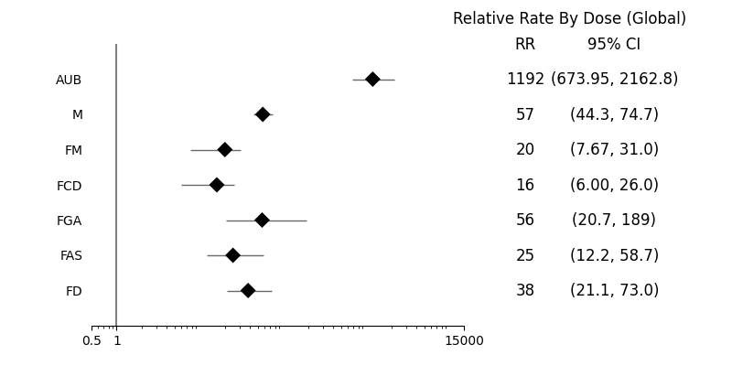

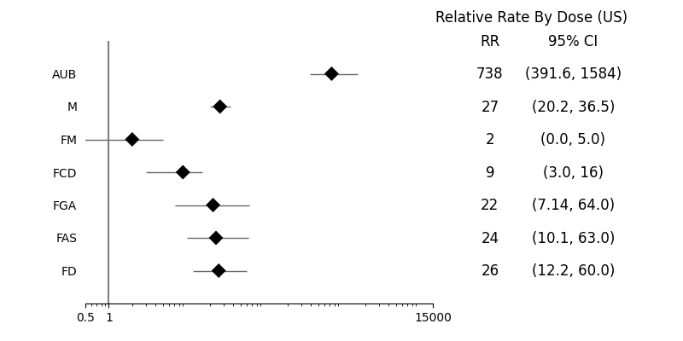

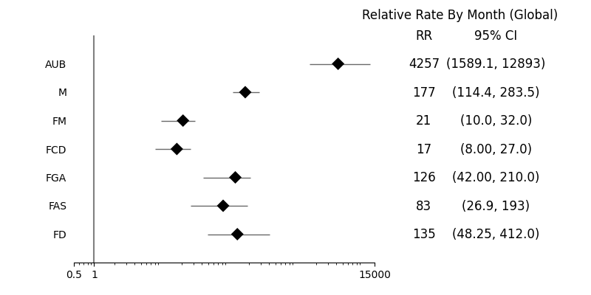

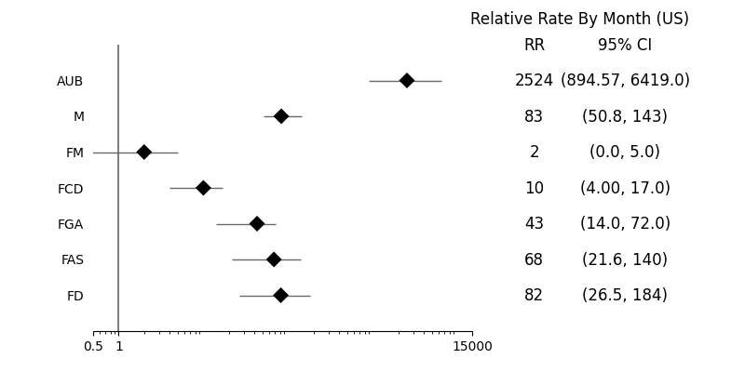

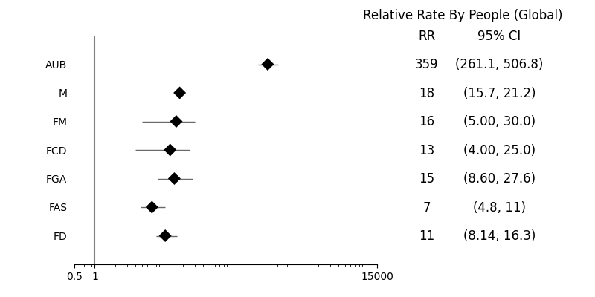

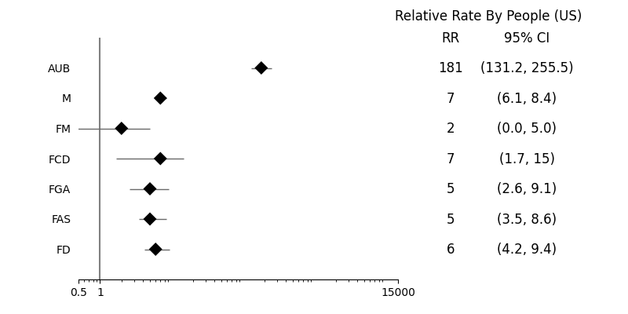

## Scripts

Private for the authors only: I have a git hub repository here and if you’re comfortable with git hub I will give you permission to clone the repo and check out what I did.

<https://github.com/mikedeskevich/fetal-ae>

## Logs

Output log from analysis code

******************************
  
***** Dose (US) *****
  
[('Abnormal uterine bleeding (menstrual irregularity)', 'AUB', 6352, 54), ('Miscarriage', 'M', 1232, 259), ('Fetal chromosomal abnormalities', 'FCM', 7, 0), ('Fetal malformation', 'FM', 2, 1), ('Fetal cystic hygroma', 'FCM', 5, 0), ('Fetal cardiac disorders', 'FCD', 10, 2), ('Fetal arrhythmia', 'FA', 3, 0), ('Fetal cardiac arrest', 'FCA', 3, 0), ('Fetal vascular mal-perfusion', 'FVMP', 5, 0), ('Fetal growth abnormalities', 'FGA', 59, 20), ('Fetal abnormal surveillance', 'FAS', 125, 36), ('Fetal placental thrombosis', 'FPT', 5, 0), ('Fetal death (stillbirth)', 'FD', 168, 42)]
  
cperiod= 0.59623
  
cperiod= 3.3
  
******************************
  
  
*** RATES ***
  
Abnormal uterine bleeding (menstrual irregularity) 6352 10653.6068 54 16.3636
  
Miscarriage 1232 2066.3167 259 78.4848
  
Fetal chromosomal abnormalities 7 11.7404 0 0.0000
  
Fetal malformation 2 3.3544 1 0.3030
  
Fetal cystic hygroma 5 8.3860 0 0.0000
  
Fetal cardiac disorders 10 16.7721 2 0.6061
  
Fetal arrhythmia 3 5.0316 0 0.0000
  
Fetal cardiac arrest 3 5.0316 0 0.0000
  
Fetal vascular mal-perfusion 5 8.3860 0 0.0000
  
Fetal growth abnormalities 59 98.9551 20 6.0606
  
Fetal abnormal surveillance 125 209.6506 36 10.9091
  
Fetal placental thrombosis 5 8.3860 0 0.0000
  
Fetal death (stillbirth) 168 281.7705 42 12.7273
  
******************************
  
  
*** P VALUES ***
  
Abnormal uterine bleeding (menstrual irregularity) 0.000e+00
  
Miscarriage 0.000e+00
  
Fetal chromosomal abnormalities 4.759e-03
  
Fetal malformation 1.973e-01
  
Fetal cystic hygroma 1.976e-02
  
Fetal cardiac disorders 5.781e-04
  
Fetal arrhythmia 8.838e-02
  
Fetal cardiac arrest 8.838e-02
  
Fetal vascular mal-perfusion 1.976e-02
  
Fetal growth abnormalities 0.000e+00
  
Fetal abnormal surveillance 0.000e+00
  
Fetal placental thrombosis 1.976e-02
  
Fetal death (stillbirth) 0.000e+00
  
******************************
  
  
*** RELATIVE RATES ***
  
Abnormal uterine bleeding (menstrual irregularity) 738.1339 391.6250 1583.5000
  
Miscarriage 26.9146 20.1833 36.5294
  
Fetal chromosomal abnormalities 0.0000 0.0000 0.0000
  
Fetal malformation 1.9072 0.0000 5.0000
  
Fetal cystic hygroma 0.0000 0.0000 0.0000
  
Fetal cardiac disorders 9.1187 3.0000 16.0000
  
Fetal arrhythmia 0.0000 0.0000 0.0000
  
Fetal cardiac arrest 0.0000 0.0000 0.0000
  
Fetal vascular mal-perfusion 0.0000 0.0000 0.0000
  
Fetal growth abnormalities 21.5757 7.1429 64.0000
  
Fetal abnormal surveillance 23.5755 10.1111 63.0000
  
Fetal placental thrombosis 0.0000 0.0000 0.0000
  
Fetal death (stillbirth) 26.2801 12.2000 60.0000
  
******************************
  
  
******************************
  
***** Month (US) *****
  
[('Abnormal uterine bleeding (menstrual irregularity)', 'AUB', 6352, 54), ('Miscarriage', 'M', 1232, 259), ('Fetal chromosomal abnormalities', 'FCM', 7, 0), ('Fetal malformation', 'FM', 2, 1), ('Fetal cystic hygroma', 'FCM', 5, 0), ('Fetal cardiac disorders', 'FCD', 10, 2), ('Fetal arrhythmia', 'FA', 3, 0), ('Fetal cardiac arrest', 'FCA', 3, 0), ('Fetal vascular mal-perfusion', 'FVMP', 5, 0), ('Fetal growth abnormalities', 'FGA', 59, 20), ('Fetal abnormal surveillance', 'FAS', 125, 36), ('Fetal placental thrombosis', 'FPT', 5, 0), ('Fetal death (stillbirth)', 'FD', 168, 42)]
  
cperiod= 18
  
cperiod= 294
  
******************************
  
  
*** RATES ***
  
Abnormal uterine bleeding (menstrual irregularity) 6352 352.8889 54 0.1837
  
Miscarriage 1232 68.4444 259 0.8810
  
Fetal chromosomal abnormalities 7 0.3889 0 0.0000
  
Fetal malformation 2 0.1111 1 0.0034
  
Fetal cystic hygroma 5 0.2778 0 0.0000
  
Fetal cardiac disorders 10 0.5556 2 0.0068
  
Fetal arrhythmia 3 0.1667 0 0.0000
  
Fetal cardiac arrest 3 0.1667 0 0.0000
  
Fetal vascular mal-perfusion 5 0.2778 0 0.0000
  
Fetal growth abnormalities 59 3.2778 20 0.0680
  
Fetal abnormal surveillance 125 6.9444 36 0.1224
  
Fetal placental thrombosis 5 0.2778 0 0.0000
  
Fetal death (stillbirth) 168 9.3333 42 0.1429
  
******************************
  
  
*** P VALUES ***
  
Abnormal uterine bleeding (menstrual irregularity) 0.000e+00
  
Miscarriage 0.000e+00
  
Fetal chromosomal abnormalities 4.759e-03
  
Fetal malformation 1.973e-01
  
Fetal cystic hygroma 1.976e-02
  
Fetal cardiac disorders 5.781e-04
  
Fetal arrhythmia 8.838e-02
  
Fetal cardiac arrest 8.838e-02
  
Fetal vascular mal-perfusion 1.976e-02
  
Fetal growth abnormalities 0.000e+00
  
Fetal abnormal surveillance 0.000e+00
  
Fetal placental thrombosis 1.976e-02
  
Fetal death (stillbirth) 0.000e+00
  
******************************
  
  
*** RELATIVE RATES ***
  
Abnormal uterine bleeding (menstrual irregularity) 2523.5285 894.5714 6419.0000
  
Miscarriage 83.4301 50.8333 143.2222
  
Fetal chromosomal abnormalities 0.0000 0.0000 0.0000
  
Fetal malformation 1.9811 0.0000 5.0000
  
Fetal cystic hygroma 0.0000 0.0000 0.0000
  
Fetal cardiac disorders 9.6984 4.0000 17.0000
  
Fetal arrhythmia 0.0000 0.0000 0.0000
  
Fetal cardiac arrest 0.0000 0.0000 0.0000
  
Fetal vascular mal-perfusion 0.0000 0.0000 0.0000
  
Fetal growth abnormalities 42.5020 14.0000 72.0000
  
Fetal abnormal surveillance 67.9890 21.6000 140.0000
  
Fetal placental thrombosis 0.0000 0.0000 0.0000
  
Fetal death (stillbirth) 82.1521 26.5000 184.0000
  
******************************
  
  
******************************
  
***** People (US) *****
  
[('Abnormal uterine bleeding (menstrual irregularity)', 'AUB', 6352, 54), ('Miscarriage', 'M', 1232, 259), ('Fetal chromosomal abnormalities', 'FCM', 7, 0), ('Fetal malformation', 'FM', 2, 1), ('Fetal cystic hygroma', 'FCM', 5, 0), ('Fetal cardiac disorders', 'FCD', 10, 2), ('Fetal arrhythmia', 'FA', 3, 0), ('Fetal cardiac arrest', 'FCA', 3, 0), ('Fetal vascular mal-perfusion', 'FVMP', 5, 0), ('Fetal growth abnormalities', 'FGA', 59, 20), ('Fetal abnormal surveillance', 'FAS', 125, 36), ('Fetal placental thrombosis', 'FPT', 5, 0), ('Fetal death (stillbirth)', 'FD', 168, 42)]
  
cperiod= 0.25996
  
cperiod= 0.38861
  
******************************
  
  
*** RATES ***
  
Abnormal uterine bleeding (menstrual irregularity) 6352 24434.5284 54 138.9568
  
Miscarriage 1232 4739.1906 259 666.4780
  
Fetal chromosomal abnormalities 7 26.9272 0 0.0000
  
Fetal malformation 2 7.6935 1 2.5733
  
Fetal cystic hygroma 5 19.2337 0 0.0000
  
Fetal cardiac disorders 10 38.4675 2 5.1465
  
Fetal arrhythmia 3 11.5402 0 0.0000
  
Fetal cardiac arrest 3 11.5402 0 0.0000
  
Fetal vascular mal-perfusion 5 19.2337 0 0.0000
  
Fetal growth abnormalities 59 226.9580 20 51.4655
  
Fetal abnormal surveillance 125 480.8432 36 92.6379
  
Fetal placental thrombosis 5 19.2337 0 0.0000
  
Fetal death (stillbirth) 168 646.2533 42 108.0775
  
******************************
  
  
*** P VALUES ***
  
Abnormal uterine bleeding (menstrual irregularity) 0.000e+00
  
Miscarriage 0.000e+00
  
Fetal chromosomal abnormalities 4.759e-03
  
Fetal malformation 1.973e-01
  
Fetal cystic hygroma 1.976e-02
  
Fetal cardiac disorders 4.682e-03
  
Fetal arrhythmia 8.838e-02
  
Fetal cardiac arrest 8.838e-02
  
Fetal vascular mal-perfusion 1.976e-02
  
Fetal growth abnormalities 1.675e-08
  
Fetal abnormal surveillance 0.000e+00
  
Fetal placental thrombosis 1.976e-02
  
Fetal death (stillbirth) 0.000e+00
  
******************************
  
  
*** RELATIVE RATES ***
  
Abnormal uterine bleeding (menstrual irregularity) 180.9633 131.2245 255.4800
  
Miscarriage 7.1526 6.1040 8.4052
  
Fetal chromosomal abnormalities 0.0000 0.0000 0.0000
  
Fetal malformation 1.6813 0.0000 5.0000
  
Fetal cystic hygroma 0.0000 0.0000 0.0000
  
Fetal cardiac disorders 6.9717 1.6667 15.0000
  
Fetal arrhythmia 0.0000 0.0000 0.0000
  
Fetal cardiac arrest 0.0000 0.0000 0.0000
  
Fetal vascular mal-perfusion 0.0000 0.0000 0.0000
  
Fetal growth abnormalities 4.8033 2.5789 9.1111
  
Fetal abnormal surveillance 5.4263 3.4857 8.5714
  
Fetal placental thrombosis 0.0000 0.0000 0.0000
  
Fetal death (stillbirth) 6.2095 4.1538 9.4375
  
******************************
  
  
******************************
  
***** Dose (Global) *****
  
[('Abnormal uterine bleeding (menstrual irregularity)', 'AUB', 12843, 65), ('Miscarriage', 'M', 3338, 325), ('Fetal chromosomal abnormalities', 'FCM', 10, 0), ('Fetal malformation', 'FM', 22, 2), ('Fetal cystic hygroma', 'FCM', 8, 0), ('Fetal cardiac disorders', 'FCD', 18, 2), ('Fetal arrhythmia', 'FA', 5, 0), ('Fetal cardiac arrest', 'FCA', 20, 0), ('Fetal vascular mal-perfusion', 'FVMP', 12, 0), ('Fetal growth abnormalities', 'FGA', 188, 24), ('Fetal abnormal surveillance', 'FAS', 178, 45), ('Fetal placental thrombosis', 'FPT', 6, 0), ('Fetal death (stillbirth)', 'FD', 402, 64)]
  
cperiod= 12.07
  
cperiod= 66
  
******************************
  
  
*** RATES ***
  
Abnormal uterine bleeding (menstrual irregularity) 12843 1064.0431 65 0.9848
  
Miscarriage 3338 276.5534 325 4.9242
  
Fetal chromosomal abnormalities 10 0.8285 0 0.0000
  
Fetal malformation 22 1.8227 2 0.0303
  
Fetal cystic hygroma 8 0.6628 0 0.0000
  
Fetal cardiac disorders 18 1.4913 2 0.0303
  
Fetal arrhythmia 5 0.4143 0 0.0000
  
Fetal cardiac arrest 20 1.6570 0 0.0000
  
Fetal vascular mal-perfusion 12 0.9942 0 0.0000
  
Fetal growth abnormalities 188 15.5758 24 0.3636
  
Fetal abnormal surveillance 178 14.7473 45 0.6818
  
Fetal placental thrombosis 6 0.4971 0 0.0000
  
Fetal death (stillbirth) 402 33.3057 64 0.9697
  
******************************
  
  
*** P VALUES ***
  
Abnormal uterine bleeding (menstrual irregularity) 0.000e+00
  
Miscarriage 0.000e+00
  
Fetal chromosomal abnormalities 5.781e-04
  
Fetal malformation 1.855e-07
  
Fetal cystic hygroma 2.378e-03
  
Fetal cardiac disorders 2.618e-06
  
Fetal arrhythmia 1.976e-02
  
Fetal cardiac arrest 6.949e-07
  
Fetal vascular mal-perfusion 1.473e-04
  
Fetal growth abnormalities 0.000e+00
  
Fetal abnormal surveillance 0.000e+00
  
Fetal placental thrombosis 9.631e-03
  
Fetal death (stillbirth) 0.000e+00
  
******************************
  
  
*** RELATIVE RATES ***
  
Abnormal uterine bleeding (menstrual irregularity) 1191.8561 673.9474 2162.8333
  
Miscarriage 57.1421 44.3421 74.6591
  
Fetal chromosomal abnormalities 0.0000 0.0000 0.0000
  
Fetal malformation 20.0241 7.6667 31.0000
  
Fetal cystic hygroma 0.0000 0.0000 0.0000
  
Fetal cardiac disorders 16.3892 6.0000 26.0000
  
Fetal arrhythmia 0.0000 0.0000 0.0000
  
Fetal cardiac arrest 0.0000 0.0000 0.0000
  
Fetal vascular mal-perfusion 0.0000 0.0000 0.0000
  
Fetal growth abnormalities 56.1703 20.6667 189.0000
  
Fetal abnormal surveillance 25.2665 12.1538 58.6667
  
Fetal placental thrombosis 0.0000 0.0000 0.0000
  
Fetal death (stillbirth) 37.9790 21.0526 73.0000
  
******************************
  
  
******************************
  
***** Month (Global) *****
  
[('Abnormal uterine bleeding (menstrual irregularity)', 'AUB', 12843, 65), ('Miscarriage', 'M', 3338, 325), ('Fetal chromosomal abnormalities', 'FCM', 10, 0), ('Fetal malformation', 'FM', 22, 2), ('Fetal cystic hygroma', 'FCM', 8, 0), ('Fetal cardiac disorders', 'FCD', 18, 2), ('Fetal arrhythmia', 'FA', 5, 0), ('Fetal cardiac arrest', 'FCA', 20, 0), ('Fetal vascular mal-perfusion', 'FVMP', 12, 0), ('Fetal growth abnormalities', 'FGA', 188, 24), ('Fetal abnormal surveillance', 'FAS', 178, 45), ('Fetal placental thrombosis', 'FPT', 6, 0), ('Fetal death (stillbirth)', 'FD', 402, 64)]
  
cperiod= 18
  
cperiod= 294
  
******************************
  
  
*** RATES ***
  
Abnormal uterine bleeding (menstrual irregularity) 12843 713.5000 65 0.2211
  
Miscarriage 3338 185.4444 325 1.1054
  
Fetal chromosomal abnormalities 10 0.5556 0 0.0000
  
Fetal malformation 22 1.2222 2 0.0068
  
Fetal cystic hygroma 8 0.4444 0 0.0000
  
Fetal cardiac disorders 18 1.0000 2 0.0068
  
Fetal arrhythmia 5 0.2778 0 0.0000
  
Fetal cardiac arrest 20 1.1111 0 0.0000
  
Fetal vascular mal-perfusion 12 0.6667 0 0.0000
  
Fetal growth abnormalities 188 10.4444 24 0.0816
  
Fetal abnormal surveillance 178 9.8889 45 0.1531
  
Fetal placental thrombosis 6 0.3333 0 0.0000
  
Fetal death (stillbirth) 402 22.3333 64 0.2177
  
******************************
  
  
*** P VALUES ***
  
Abnormal uterine bleeding (menstrual irregularity) 0.000e+00
  
Miscarriage 0.000e+00
  
Fetal chromosomal abnormalities 5.781e-04
  
Fetal malformation 1.855e-07
  
Fetal cystic hygroma 2.378e-03
  
Fetal cardiac disorders 2.618e-06
  
Fetal arrhythmia 1.976e-02
  
Fetal cardiac arrest 6.949e-07
  
Fetal vascular mal-perfusion 1.473e-04
  
Fetal growth abnormalities 0.000e+00
  
Fetal abnormal surveillance 0.000e+00
  
Fetal placental thrombosis 9.631e-03
  
Fetal death (stillbirth) 0.000e+00
  
******************************
  
  
*** RELATIVE RATES ***
  
Abnormal uterine bleeding (menstrual irregularity) 4256.6142 1589.1250 12893.0000
  
Miscarriage 177.1452 114.4138 283.5000
  
Fetal chromosomal abnormalities 0.0000 0.0000 0.0000
  
Fetal malformation 21.3265 10.0000 32.0000
  
Fetal cystic hygroma 0.0000 0.0000 0.0000
  
Fetal cardiac disorders 17.4539 8.0000 27.0000
  
Fetal arrhythmia 0.0000 0.0000 0.0000
  
Fetal cardiac arrest 0.0000 0.0000 0.0000
  
Fetal vascular mal-perfusion 0.0000 0.0000 0.0000
  
Fetal growth abnormalities 126.2765 42.0000 210.0000
  
Fetal abnormal surveillance 82.6192 26.8571 193.0000
  
Fetal placental thrombosis 0.0000 0.0000 0.0000
  
Fetal death (stillbirth) 135.3308 48.2500 412.0000
  
******************************
  
  
******************************
  
***** People (Global) *****
  
[('Abnormal uterine bleeding (menstrual irregularity)', 'AUB', 12843, 65), ('Miscarriage', 'M', 3338, 325), ('Fetal chromosomal abnormalities', 'FCM', 10, 0), ('Fetal malformation', 'FM', 22, 2), ('Fetal cystic hygroma', 'FCM', 8, 0), ('Fetal cardiac disorders', 'FCD', 18, 2), ('Fetal arrhythmia', 'FA', 5, 0), ('Fetal cardiac arrest', 'FCA', 20, 0), ('Fetal vascular mal-perfusion', 'FVMP', 12, 0), ('Fetal growth abnormalities', 'FGA', 188, 24), ('Fetal abnormal surveillance', 'FAS', 178, 45), ('Fetal placental thrombosis', 'FPT', 6, 0), ('Fetal death (stillbirth)', 'FD', 402, 64)]
  
cperiod= 5.23
  
cperiod= 9.23
  
******************************
  
  
*** RATES ***
  
Abnormal uterine bleeding (menstrual irregularity) 12843 2455.6405 65 7.0423
  
Miscarriage 3338 638.2409 325 35.2113
  
Fetal chromosomal abnormalities 10 1.9120 0 0.0000
  
Fetal malformation 22 4.2065 2 0.2167
  
Fetal cystic hygroma 8 1.5296 0 0.0000
  
Fetal cardiac disorders 18 3.4417 2 0.2167
  
Fetal arrhythmia 5 0.9560 0 0.0000
  
Fetal cardiac arrest 20 3.8241 0 0.0000
  
Fetal vascular mal-perfusion 12 2.2945 0 0.0000
  
Fetal growth abnormalities 188 35.9465 24 2.6002
  
Fetal abnormal surveillance 178 34.0344 45 4.8754
  
Fetal placental thrombosis 6 1.1472 0 0.0000
  
Fetal death (stillbirth) 402 76.8642 64 6.9339
  
******************************
  
  
*** P VALUES ***
  
Abnormal uterine bleeding (menstrual irregularity) 0.000e+00
  
Miscarriage 0.000e+00
  
Fetal chromosomal abnormalities 5.781e-04
  
Fetal malformation 2.096e-06
  
Fetal cystic hygroma 2.378e-03
  
Fetal cardiac disorders 2.707e-05
  
Fetal arrhythmia 1.976e-02
  
Fetal cardiac arrest 6.949e-07
  
Fetal vascular mal-perfusion 1.473e-04
  
Fetal growth abnormalities 0.000e+00
  
Fetal abnormal surveillance 0.000e+00
  
Fetal placental thrombosis 9.631e-03
  
Fetal death (stillbirth) 0.000e+00
  
******************************
  
  
*** RELATIVE RATES ***
  
Abnormal uterine bleeding (menstrual irregularity) 358.6413 261.0816 506.7602
  
Miscarriage 18.2268 15.7302 21.1975
  
Fetal chromosomal abnormalities 0.0000 0.0000 0.0000
  
Fetal malformation 16.2592 5.0000 30.0000
  
Fetal cystic hygroma 0.0000 0.0000 0.0000
  
Fetal cardiac disorders 13.2949 4.0000 25.0000
  
Fetal arrhythmia 0.0000 0.0000 0.0000
  
Fetal cardiac arrest 0.0000 0.0000 0.0000
  
Fetal vascular mal-perfusion 0.0000 0.0000 0.0000
  
Fetal growth abnormalities 15.0360 8.6000 27.6250
  
Fetal abnormal surveillance 7.2770 4.7895 11.2667
  
Fetal placental thrombosis 0.0000 0.0000 0.0000
  
Fetal death (stillbirth) 11.4116 8.1364 16.2917
  
******************************

Output log from the flu vaccine population simulation

|End of Year|Sample Population<br/>(Thousands)|Vaccinated Population<br/>(Thousands)|Total Vaccinated<br/>Since 1998<br/>(Thousands)|  
|---| --: | --: | --: |  
| 1980 | 100685 | 70921 (70.4%) | -- |  
| 1981 | 101328 | 82921 (81.8%) | -- |  
| 1982 | 101936 | 89923 (88.2%) | -- |  
| 1983 | 102629 | 94190 (91.8%) | -- |  
| 1984 | 103253 | 96842 (93.8%) | -- |  
| 1985 | 103924 | 98746 (95.0%) | -- |  
| 1986 | 104615 | 100133 (95.7%) | -- |  
| 1987 | 105344 | 101170 (96.0%) | -- |  
| 1988 | 106017 | 102026 (96.2%) | -- |  
| 1989 | 106742 | 102790 (96.3%) | -- |  
| 1990 | 107434 | 103590 (96.4%) | -- |  
| 1991 | 108187 | 104335 (96.4%) | -- |  
| 1992 | 108919 | 105104 (96.5%) | -- |  
| 1993 | 109637 | 105790 (96.5%) | -- |  
| 1994 | 110313 | 106507 (96.5%) | -- |  
| 1995 | 110959 | 107191 (96.6%) | -- |  
| 1996 | 111615 | 107893 (96.7%) | -- |  
| 1997 | 112289 | 108579 (96.7%) | -- |  
| 1998 | 112919 | 109203 (96.7%) | 110157 (97.6%) |  
| 1999 | 113542 | 109799 (96.7%) | 111722 (98.4%) |  
| 2000 | 114182 | 110390 (96.7%) | 113264 (99.2%) |  
| 2001 | 114821 | 111055 (96.7%) | 114889 (100.1%) |  
| 2002 | 115497 | 111745 (96.8%) | 116497 (100.9%) |  
| 2003 | 116175 | 112461 (96.8%) | 118139 (101.7%) |  
| 2004 | 116819 | 113102 (96.8%) | 119745 (102.5%) |  
| 2005 | 117465 | 113757 (96.8%) | 121371 (103.3%) |  
| 2006 | 118119 | 114412 (96.9%) | 122989 (104.1%) |  
| 2007 | 118792 | 114997 (96.8%) | 124521 (104.8%) |  
| 2008 | 119496 | 115736 (96.9%) | 126181 (105.6%) |  
| 2009 | 120074 | 116317 (96.9%) | 127789 (106.4%) |  
| 2010 | 120665 | 116899 (96.9%) | 129362 (107.2%) |  
| 2011 | 121265 | 117562 (96.9%) | 130979 (108.0%) |  
| 2012 | 121819 | 118175 (97.0%) | 132571 (108.8%) |  
| 2013 | 122308 | 118774 (97.1%) | 134195 (109.7%) |  
| 2014 | 122830 | 119335 (97.2%) | 135733 (110.5%) |  
| 2015 | 123360 | 119866 (97.2%) | 137231 (111.2%) |  
| 2016 | 123855 | 120378 (97.2%) | 138736 (112.0%) |  
| 2017 | 124287 | 120819 (97.2%) | 140225 (112.8%) |  
| 2018 | 124730 | 121263 (97.2%) | 141695 (113.6%) |  
| 2019 | 125123 | 121666 (97.2%) | 143178 (114.4%) |  
| 2020 | 125570 | 122107 (97.2%) | 144657 (115.2%) |  
| 2021 | 125981 | 122575 (97.3%) | 146200 (116.0%) |  
  
US total Flu vaccine since 1998 = 388538000  
Global total Flu vaccine since 1998 = 9230502000

## Extra

![[Abnormal uterine bleeding (menstrual irregularity)-Dose (Global)](Abnormal%20uterine%20bleeding%20(menstrual%20irregularity)-Dose%20(Global).png)

